|  |
| --- |
| **Generative AI tools cannot be used in this assessment task** In this assessment, you must **not** use generative artificial intelligence (AI) to generate any materials or content in relation to the assessment task. |

**FIT3081 Image Processing - Take Home Assessment (S1, 2023)**

**(Due 11.55 p.m. on 9th Jun 2023)**

**[Weight: 30 marks]**

# Overview

You are given an image dataset with 15 class that **contains 5 Numerals and 10 Alphabets**. Each class will have 10 Images. Hence, the **total number of images is 150**. With the given dataset, you need to use **80% for training and the remaining 20% for testing**. An example of a Table below shows the naming of the images for training and testing.

We used a random number generator to assign 150 images for each dataset. There are 80 students in this course, and each will have a dataset that is different from the others. Each will be given a random seed number to be used in initializing the weights during the training phase of the neural network.

**Please note: The neural network that will be used in this take-home assessment is the same as in assignment 3.**

# Question Layout

There are **three questions** to be answered in this take-home assessment.

Question 1 requires you to use Sobel Magnitude followed by threshold. There are 5 experiments to be answered in this question. You need to fill up the given Tables for all 5 experiments.

Question 2 requires you to propose an algorithm that performs better than the accuracies obtained in Question 1. Here too, you have to fill up the Table and besides that, the description of the proposed method is required.

Question 3 is about error weight correction.

# Marks allocation

Those who have been very involved in assignment 3, will realize several factors affect the testing accuracy. In our case, we are using a small model and hence there is a chance that in some cases, the training data set and the type of inputs used, which is fixed for **experiments 1 to 5**, may not give higher accuracies when compared to other training datasets.

We used several of the datasets (9 of them) and found that the accuracies for experiment 1 varied from 53% to 70% for 1000 epochs. One epoch means that the learning algorithm will work through the entire training dataset. In our case, one epoch will take 120 iterations to go through the entire training set.

We have indicated an expected accuracy for the second and third experiments by comparing them with experiment 1.

**Table: Layout of the naming of the images used in training and testing**

|  |  |  |  |  |  |  |  |  |  |  |
| --- | --- | --- | --- | --- | --- | --- | --- | --- | --- | --- |
| **Images chosen for experiments** | **Training Images** | | | | | | | | **Testing Images** | |
| A | A1 | A2 | A3 | A4 | A5 | A6 | A7 | A8 | A9 | A10 |
| D | D1 | D2 | D3 | D4 | D5 | D6 | D7 | D8 | D9 | D10 |
| F | F1 | F2 | F3 | F4 | F5 | F6 | F7 | F8 | F9 | F10 |
| G | G1 | G2 | G3 | G4 | G5 | G6 | G7 | G8 | G9 | G10 |
| H | H1 | H2 | H3 | H4 | H5 | H6 | H7 | H8 | H9 | H10 |
| K | K1 | K2 | K3 | K4 | K5 | K6 | K7 | K8 | K9 | K10 |
| M | M1 | M2 | M3 | M4 | M5 | M6 | M7 | M8 | M9 | M10 |
| O | O1 | O2 | O3 | O4 | O5 | O6 | O7 | O8 | O9 | O10 |
| Q | Q1 | Q2 | Q3 | Q4 | Q5 | Q6 | Q7 | Q8 | Q9 | Q10 |
| S | S1 | S2 | S3 | S4 | S5 | S6 | S7 | S8 | S9 | S10 |
| 1 | 1a | 1b | 1c | 1d | 1e | 1f | 1g | 1h | 1i | 1j |
| 2 | 2a | 2b | 2c | 2d | 2e | 2f | 2g | 2h | 2i | 2j |
| 4 | 4a | 4b | 4c | 4d | 4e | 4f | 4g | 4h | 4i | 4j |
| 7 | 7a | 7b | 7c | 7d | 7e | 7f | 7g | 7h | 7i | 7j |
| 9 | 9a | 9b | 9c | 9d | 9e | 9f | 9g | 9h | 9i | 9j |

# QUESTION 1 (Total 18 Marks):

There are five experiments to be carried out. Follow the instructions given in each experiment. You need to write a Python program to implement the instructions given in each experiment. Train the neural network with the training images and test the images with the remaining 20% of testing images.

## Experiment 1 (6 Marks): Expected accuracy (varies from 53% onwards)

You are required to **apply the Sobel operator** to the image dataset given and **followed by a threshold number to binarize the images** for Training and Testing. **NO LIBRARY FUNCTION using SOBEL is allowed**. Those who did use it will have 1 point deducted.

Fill up the Table below after you have completed this experiment. (2 Marks)

|  |  |
| --- | --- |
| **Items** | **Your Answer** |
| **Seed number used to initialize the random weights and bias** | 110 |
| **What is the threshold number used to binarize the images?** | 75 |
| **Number of Inputs** | 784 |
| **Number of Hidden Neurons** | 200 |
| **Global Error** | 13.0002518631163 |
| **Number of Epoch / Iteration** | 1000 |
| **Testing Accuracy** | 16/30 = 0.533 |
| **List the images correctly classified with their output values** | *2i[0.03328454]* *2j[0.01937495]* *3i[0.99850993]* *7j[0.99789772]* *9i[0.92008539]* *9j[0.98916677]* *A9[0.00295061]* *J9[0.99517143]* *L9[0.9907269]* *L10[0.99964013]* *P9[0.00780434]* *P10[0.27169886]* *W9[0.85181296]* *W10[0.85241472]* *X9[0.99996764]* *X10[0.27865581]* |
| **Instead of using the Magnitude, the Orientation angle is used where they are grouped into 8 different bins (45 degrees each). Will there be a change in the accuracy obtained? State the reason(s) for your answer.** (2 marks)  Yes, it will change cause without magnitude will lose some information about the strong and weak edges. Besides, the use of orientation angles can make edge detection more sensitive to noise. Noise in an image can introduce variations in orientation angles that may not necessarily correspond to actual edges. Which will also cause reduced accuracy. Using only an orientation angle might be insufficient for detecting the feature accurately. | |
| **It was found, that one of the reasons for lower accuracy was that some of the testing images were shifted form of the training images. Suggest a solution that can deal with this problem that still uses the binarized values obtained from the Sobel algorithm. Your solution uses the binarized values of the image to produce a new set of outputs that are used for training and testing of the neural network.** (2 marks)  Determine a set of augmentation transformations that will simulate the shifts in the binarized testing images. Then apply it to the training dataset to train the neuron network which considered different transformations of the images. | |

## Experiment 2 (4 Marks): Expected accuracy (improved accuracy than experiment 1)

In this experiment, you need to **reorganize the number of inputs to 49**. Suggest a method that can reduce the initial 784 inputs to 49 inputs obtained using the algorithm mentioned in experiment 1. Train and test the neural network using these 49 inputs. Note that **your accuracy obtained should be better than the accuracy obtained in Experiment 1.**

Fill up the Table below after you have completed this experiment. (2 Marks)

|  |  |
| --- | --- |
| **Items** | **Your Answer** |
| **Seed number used to initialize the random weights and bias** | *110* |
| **Number of Inputs** | **49** |
| **What is the threshold number used to binarize the images?** | 75 |
| **Number of Hidden Neurons** | 20 |
| **Global Error** | 1.507 |
| **Number of Epoch / Iteration** | 1000 |
| **Testing Accuracy** | 19/30=0.633 |
| **List the images correctly classified with their output values** | *3i[0.96218869]* *3j[0.9148675]* *4i[0.17330223]* *4j[0.21768183]* *7i[0.90877901]* *7j[0.92953208]* *9i[0.01965154]* *9j[0.25350747]* *A9[0.91031252]* *E9[0.94351146]* *E10[0.65690587]* *I9[0.9256131]* *I10[0.91621821]* *L9[0.98701003]* *L10[0.99770058]* *O10[0.15981924]* *T9[0.95810895]* *W9[0.40182306]* *W10[0.84518572]* |
| **Discuss your algorithm used in this experiment and compare the accuracy between this experiment with experiment 1. What could be the reason(s) for improved accuracy?** (2 marks)  I changed the size of the image from 28*28 to 7*7 with mean pooling. We can see that it gives higher accuracy as we make the properties of the images larger at the end which might help | |

## Experiment 3 (4 Marks): Expected accuracy (same or slightly lower than experiment 1)

In this experiment, the **number of inputs is further reduced to 16**. Suggest a method to do that. Again, the accuracy is dependent on the type of dataset used. The accuracy obtained is about the **same or slightly lower than the accuracy obtained in Experiment 1**.

Fill up the Table below after you have completed this experiment. (2 Marks).

|  |  |
| --- | --- |
| **Items** | **Your Answer** |
| **Seed number used to initialize the random weights and bias** | *110* |
| **Number of Inputs** | **16** |
| **Threshold number used to binarize the images.** | 75 |
| **Number of Hidden Neurons** | 10 |
| **Global Error** | 19.6234 |
| **Number of Epoch / Iteration** | 1000 |
| **Testing Accuracy** | 9/30=0.3 |
| **List the images correctly classified with their output values** | *2i[0.23664807]* *2j[0.08183264]* *7j[0.45675122]* *9i[0.96083641]* *L9[0.97741557]* *O10[0.75703933]* *T9[0.99304432]* *T10[0.99072705]* *W10[0.63568668]* |
| **Discuss your algorithm used in this experiment and compare the accuracy between this experiment with experiment 1.** (2 marks)  It has lower accuracy compared to Experiment 1 as it may over pooling the image will make the significant feature being removed from the image. | |

## Experiment 4 (2 Marks):

The testing images are **added with Gaussian Noise** where the **standard derivation is 1.0** and they are **tested using the weights obtained in Experiment 1.** Write a program to add Gaussian noise to the testing images.

Fill up the Table below after you have completed this experiment. (1 Mark)

|  |  |
| --- | --- |
| **Items** | **Your Answer** |
| **Testing Accuracy** | 4/30 = 0.1333 |
| **List the images correctly classified with their output values** | L9[0.00199113], O9[0.02519038], X9[0.15287974], X10[0.0001121] |
| **Are there any differences between the results obtained in Experiment 1 and the results obtained after adding Gaussian noise to the testing images? State the reason(s), if any for the differences in the testing accuracies between them. (1 Mark)**  It got less accuracy compared to Experiment 1 as we added noise in so the neuron network can’t determine the feature probably. The noise might affect the feature of the images as they will be linked as an edge with the noise. | |

## Experiment 5 (2 Marks):

In experiment 4, the testing images were added with Gaussian noise. In this experiment**, propose a method to remove the Gaussian noise**. Write a program to do that. To know the effectiveness of your proposed method, the testing images with the Gaussian noise removed are tested using the weights obtained in experiment 1.

Fill up the Table below after you have completed this experiment. (1 Mark)

|  |  |
| --- | --- |
| **Items** | **Your Answer** |
| **Testing Accuracy** | 9/30 = 0.3 |
| **List the images correctly classified with their output values** | 2j[0.00047732], 7i[0.00350076], 9i[0.35619461], 9j[0.33129409], A9[0.00748347], L9[0.7808642], L10[0.00084523], X9[0.0480029], X10[0.11969421] |
| **Are there any differences between the results obtained in Experiment 1 and the results obtained after implementing the proposed method to remove the Gaussian noise? State the reason(s), if any for the differences in the testing accuracies. (1 Mark)**  Yes, it still has lesser accuracy compared to Experiment 1 but is slightly higher than Experiment 4. It is because removing the noise will also remove some of the properties of the image itself so this will cause lower accuracy. | |

# QUESTION 2 (Total 10 Marks):

1. The testing accuracies obtained using the Sobel method followed by a threshold in the earlier experiments can be improved. **Propose an algorithm that can improve their testing accuracies.** Together with a **flowchart**, describe the details of the proposed method. (3 Marks)

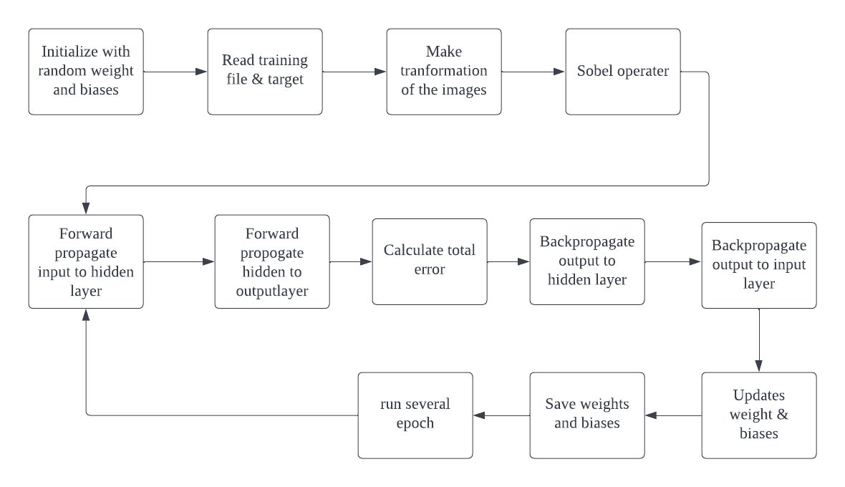

1. **Write a program to implement the proposed algorithm** that performs better than the accuracies obtained in experiments 1, 2, and 3. (4 Marks)

Fill up the Table (2 Marks)

|  |  |
| --- | --- |
| **Items** | **Your Answer** |
| **Seed number used to initialize the random weights and bias** | 110 |
| **Number of Inputs** | 784 |
| **Threshold number used to binarize the images (Optional)** | 75 |
| **Number of Hidden Neurons** | 200 |
| **Global Error** | 12.5012 |
| **Number of Epoch / Iteration** | 1000 |
| **Testing Accuracy** | 21/30=0.7 |
| **List the images correctly classified with their output values** | *3j[0.01426874] 4i[0.99612407] 4j[0.96820877] 7i[0.90414571]* *7j[0.99842886]* *9i[0.98933135]* *E10[0.93184623]* *I9[0.99977716]* *I10[0.83316194]* *J9[0.99069548]* *J10[0.0223419]* *L9[0.99937157]* *L10[0.99843168]* *P9[0.82747274]* *P10[0.27168986]* *T9[0.99987539]* *T10[0.99073385]* *W9[0.85106231]* *W10[0.24505983]* *X9[0.99741995]* *X10[0.29074871]* |
| **Compare the proposed method's accuracy with the highest accuracy obtained from experiments 1 or 2 or 3. State the reason(s) for a better performance achieved using the proposed method. (1 Mark)**  From this question, I got 21 out of 13 which is higher than experiment 2 (19/30). In this question, I used to add more transformation of the image that we read and made rotation and shifting of the image and these images can make the neuron network to detect the feature more accurately. | |

# QUESTION 3 (Total 2 Marks):

This is regarding error correction of the weights in the output layer and hidden layer. We have developed the error correction equations for both cases where all the neurons in the 3-layered neural network used the sigmoid function as the activation function. The equations used for error weight correction are:

(1)

$∂{wk}_{mn}=\left({Out}_{m}^{k} -{Target}_{m}\right) *{Out}_{m}^{k} \left(1-{Out}_{m}^{k}\right)$ ${Out}_{n}^{j}$

(2)

$∂{wj}_{mn}=x_{n} *{Out}_{m}^{j} \left(1-{Out}_{m}^{j}\right)$ $* \sum_{l=0}^{n}{{ δ}_{l}^{k} *{wk}_{lm} }$

$${ where δ}_{l}^{k} =\left({Out}_{l}^{k} -{Target}_{l}\right) *{Out}_{l}^{k} \left(1-{Out}_{l}^{k}\right)$$

Given below is a 3-layered neural network with their labelled weights. All the neurons used the sigmoid function except one neuron drawn in red (Hidden neuron 1) in the hidden layer. For this neuron, we use the **hyperbolic tangent as an activation function**. Can we still use the same equations 1 and 2 during the error correction of weights?

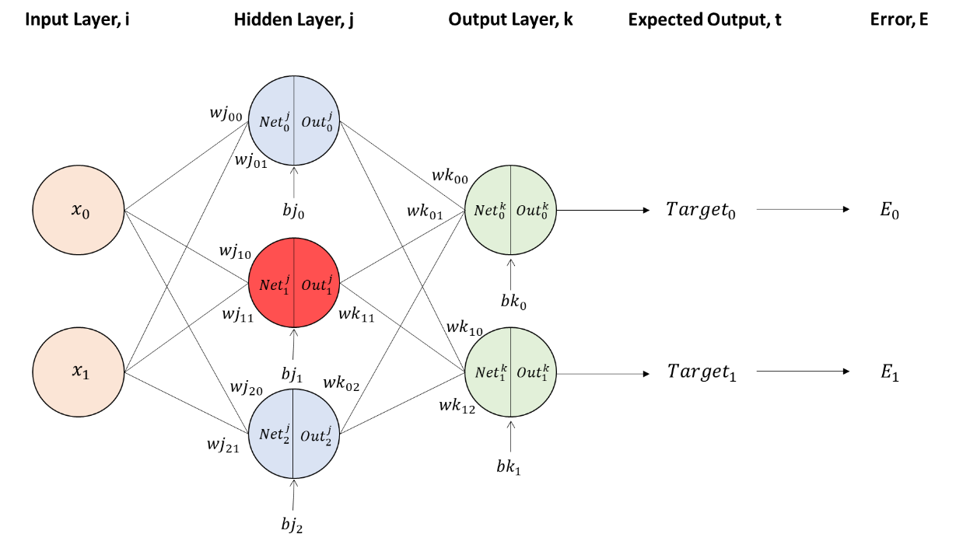

**Answer Yes or No with a reason for your choice for each weight given below:**

|  |  |  |
| --- | --- | --- |
| **Weights** | **Yes/No** | **Your reason for Yes/No** |
| $${wk}_{00}$$ | **Yes** | **For the error correction, the outjn for wk00 used outj0 as it is not affecting the calculation of the error correction** |
| $${wk}_{01}$$ | **No** | **The outjn for wk01 used outj1as it will affect the calculation of the error correction** |
| $${wj}_{00}$$ | **Yes** | **For the error correction, the outjm for wj00 used outj0 as it is not affecting the calculation of the error correction** |
| $${wj}_{10}$$ | **No** | **The outjm for wj10 used outj1 as it will affect the calculation of the error correction** |

**====== END OF QUESTIONS ======**

# Submission Details

Submit the following Files. Please follow a naming convention that is easy for us to test them. For example, in Experiment 1, please use yourName_P1 and yourName_Exp1_Weights for the program and Experiment 1 weights. Follow the same naming convention for the remaining experiments.

For question 2, please use yourName_Q2 and yourName_Q2_Weights for the program and the weights obtained using the proposed method.

1. Program file for experiment 1. (yourName_P1)
2. Weights obtained in the training of neural network for experiment 1. (yourName_Exp1_Weights)
3. Program file for experiment 2. (yourName_P2)
4. Weights obtained in the training of neural network for experiment 2. (yourName_Exp2_Weights)
5. Program file for experiment 3. (yourName_P3)
6. Weights obtained in the training of neural network for experiment 3. (yourName_Exp3_Weights)
7. Program file for experiment 4 (add Gaussian noise). (yourName_P4)
8. Program file for experiment 5 (removal of Gaussian noise). (yourName_P5)
9. Program file for the proposed method in Question 2. (yourName_Q2)
10. Weights obtained in the training of neural networks for the proposed method. (yourName_Q2_Weights)